

# Big Button Corded Landline Phone

## Type of device: Landline - Standard

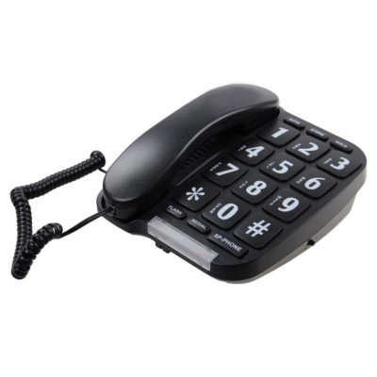

Button Type : Physical Keypad

Average Price : $89 as of 29 06 2022

## Accessibility Features:

### Hearing Impairment and Deaf

* Hearing Aid Microphone Coupling
* Hearing Aid Telecoil Coupling

Visual Alerts - Incoming Calls

### Vision

* Key Numbers - Standard Layout

Key Press - Vibration or Click

### Physical

* Flat Back for Table Top Operation

Physical Dialling Keys

## How and where to get it from?

You can buy this phone from [Big Button Corded LandLine Phone Website](https://www.bigbuttons.com.au/landline-phones/big-button-corded-landline-phone.html), and other retailers.

## More information is available on:

[Big Button Corded LandLine Phone Website](https://www.bigbuttons.com.au/landline-phones/big-button-corded-landline-phone.html)